Facility Name: _______________________________________

Date: _______________________________________

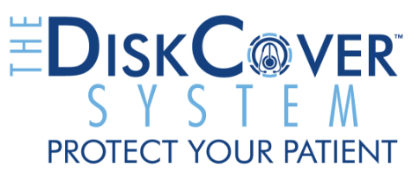
Please circle one answer for each question.
- Have you participated in this survey before?
Yes | No
- What is your clinical profession?
RN | MD | NP | PA | Other
- Which statement best describes your experience applying a DiskCover to your stethoscope?
Very hard 1 | Hard 2 | Not hard or easy 3 | Easy 4 | Very easy 5
- Compared to a disposable stethoscope, your stethoscope with a DiskCover performs?
Significantly Worse 1|Slightly Worse 2 | No Difference 3 | Slightly Better 4 |Significantly Better 5

- How often do you clean your stethoscope with alcohol for 60 seconds, as recommended by the CDC?
Between every patient 1|Between every few patients 2 | Daily 3 | Weekly 4 | Monthly 5 Never 6
- Does the DiskCover System impact your workflow?
Significantly disrupts workflow 1 | Slightly disrupts workflow 2 | No impact 3 | Slightly improves workflow 4 | Significantly improves workflow 5

- As an alternative to cleaning between patients, how do you think the DiskCover System will impact STETHOSCOPE HYGIENE COMPLIANCE among the medical staff?
Significantly worsen compliance 1 | Slightly worsen compliance 2 | No impact 3 | Slightly improve compliance 4 | Significantly improve compliance 5
- How do you think the DiskCover system will impact PATIENT SAFETY?
Significantly worsen 1 | Slightly worsen 2 | No impact 3 | Slightly improve 4 | Significantly improve 5

- Where is the DiskCover System best placed for optimum workflow and stethoscope hygiene compliance?
1 As close to the patient as possible
2 Outside the patient’s room
3 In the same place as the hand hygiene
4 At the nursing station
- Based on your experience with the DiskCover System, and as compared to your current practice, do you see applicability of touch-free dispensing as valuable for other infection vectors (ultrasound probes, hands, etc.)?
Absolutely not 1 | No 2 | Maybe 3 | Yes 4 | Absolutely yes 5
- Additional comments and feedback:

____________________________________________________________________________
Thank you!

